CCCCCCC `

Grade 2
English
Workbook
Term 2

Index
Week 1-2: Seasons
Week 3, 4: Creatures living in water, ocean, river and pond
Week 5, 6&7: Animals and their shelters
Week 8-9: Farm Animals and wild animals

Theme: Seasons
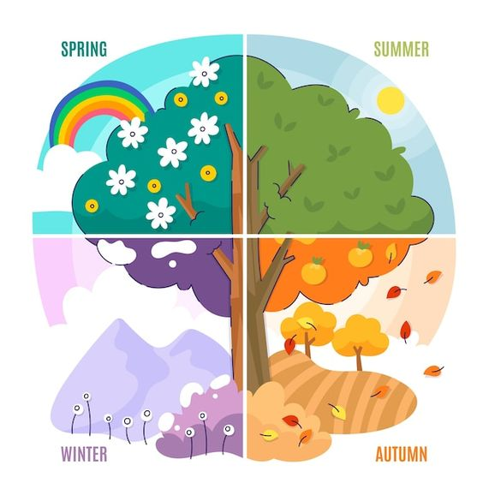
Introduction

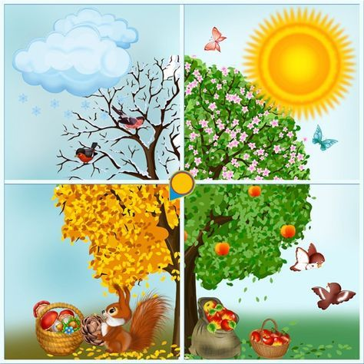

Group 1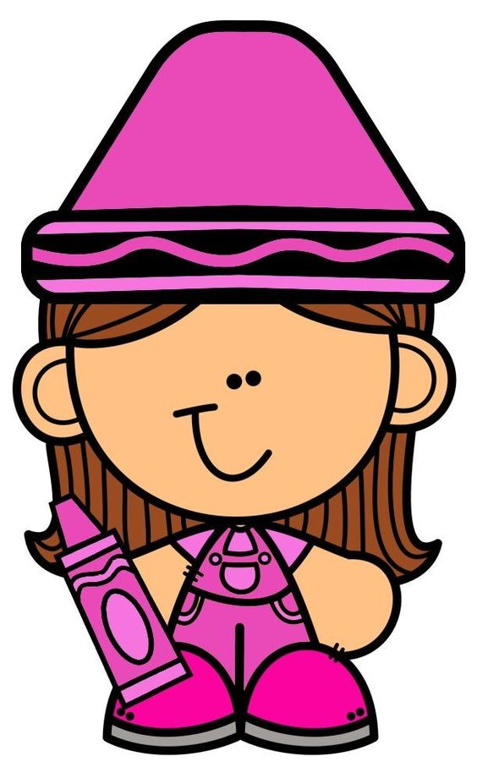

Date: _______________
Colour in the picture of the four sesons.
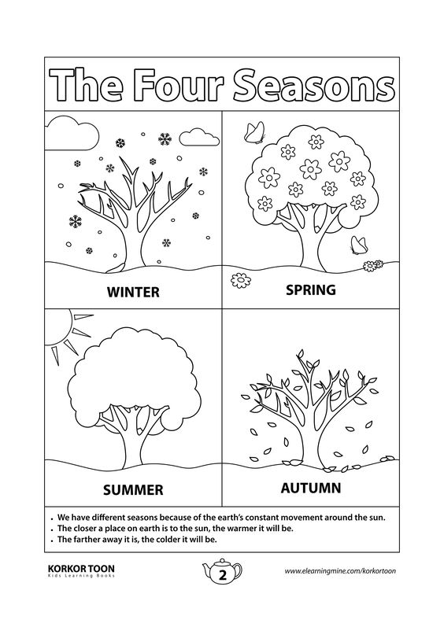

[4 marks]
Date: ___________
Colour in the picture below.
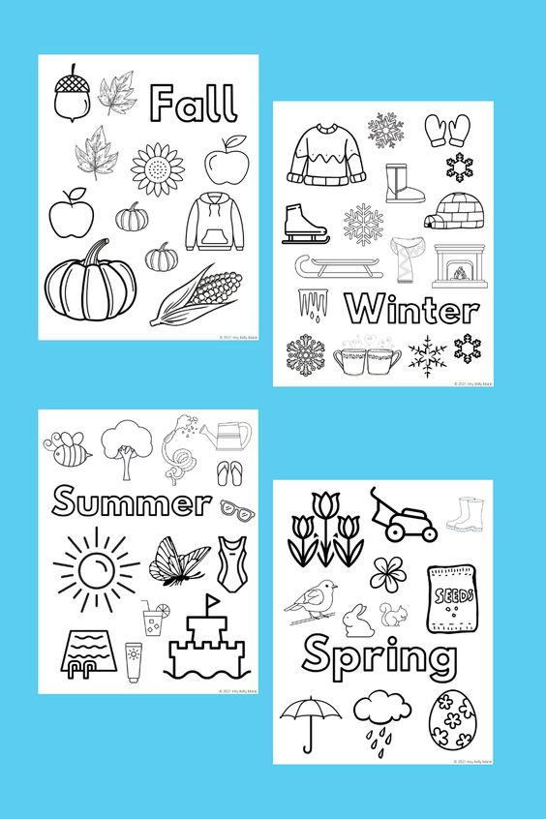
[8 marks]
Date: _____________
Match with the correct picture.

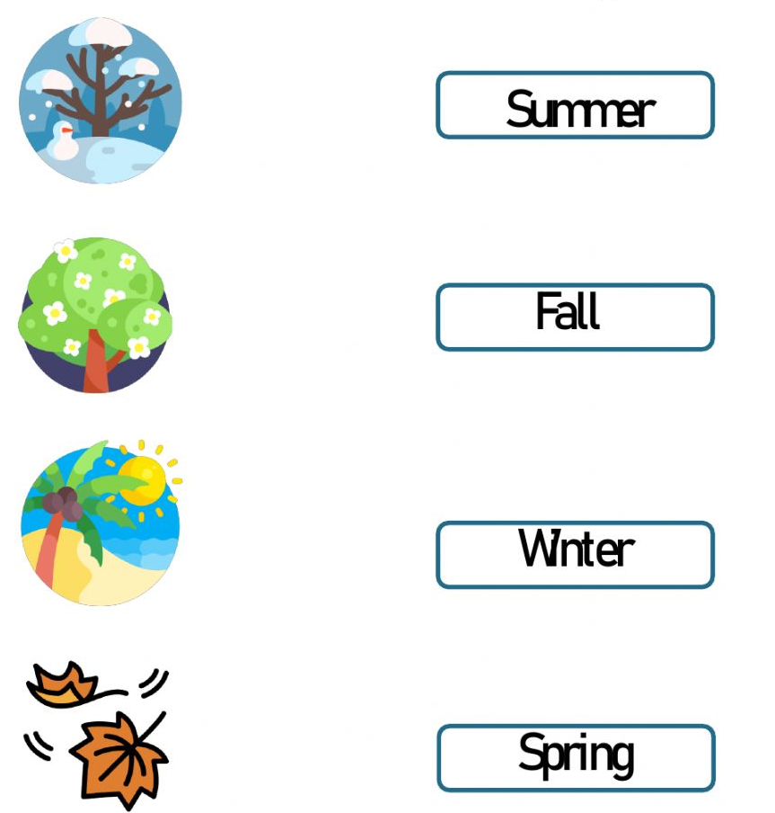
[4 marks]
Group 2

Date: _____________
What season is shown in each picture?
Tick off the correct answers.

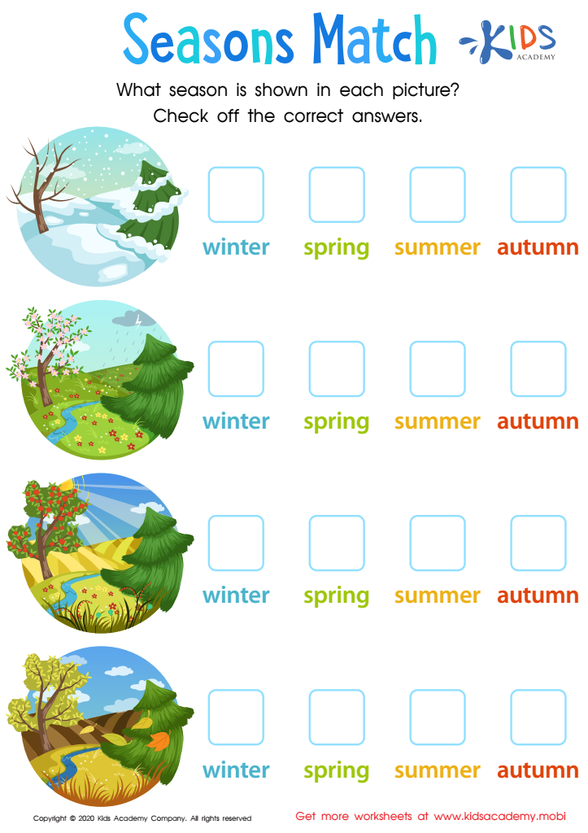
[4 marks]

Date: _____________
The four seasons
Colour the picture and draw lines to match the pictures to the seasons.

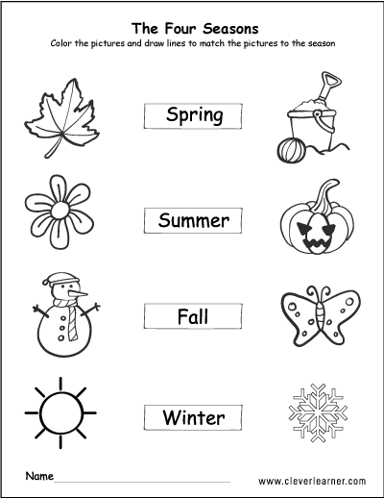
[8 marks]
Date: ____________
Write the name of the season on the lines.
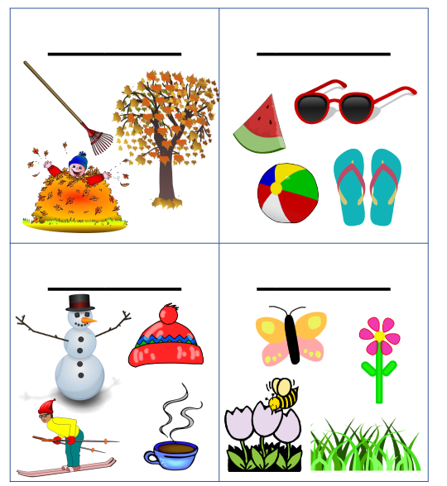
[4 marks]

Date: ____________
Choose the correct word and label the season.
summer | Autumn | Winter | Spring

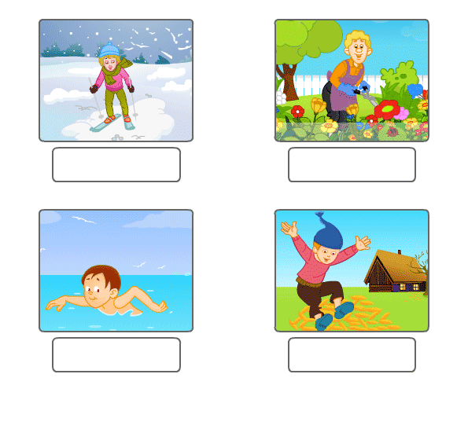
[4 marks]
Group 3

Date: ______________
Seasons
Look at the picture and write the correct word on the lines.
spring | summer | fall | winter | hot
cold | weather | cool | warm | seasons

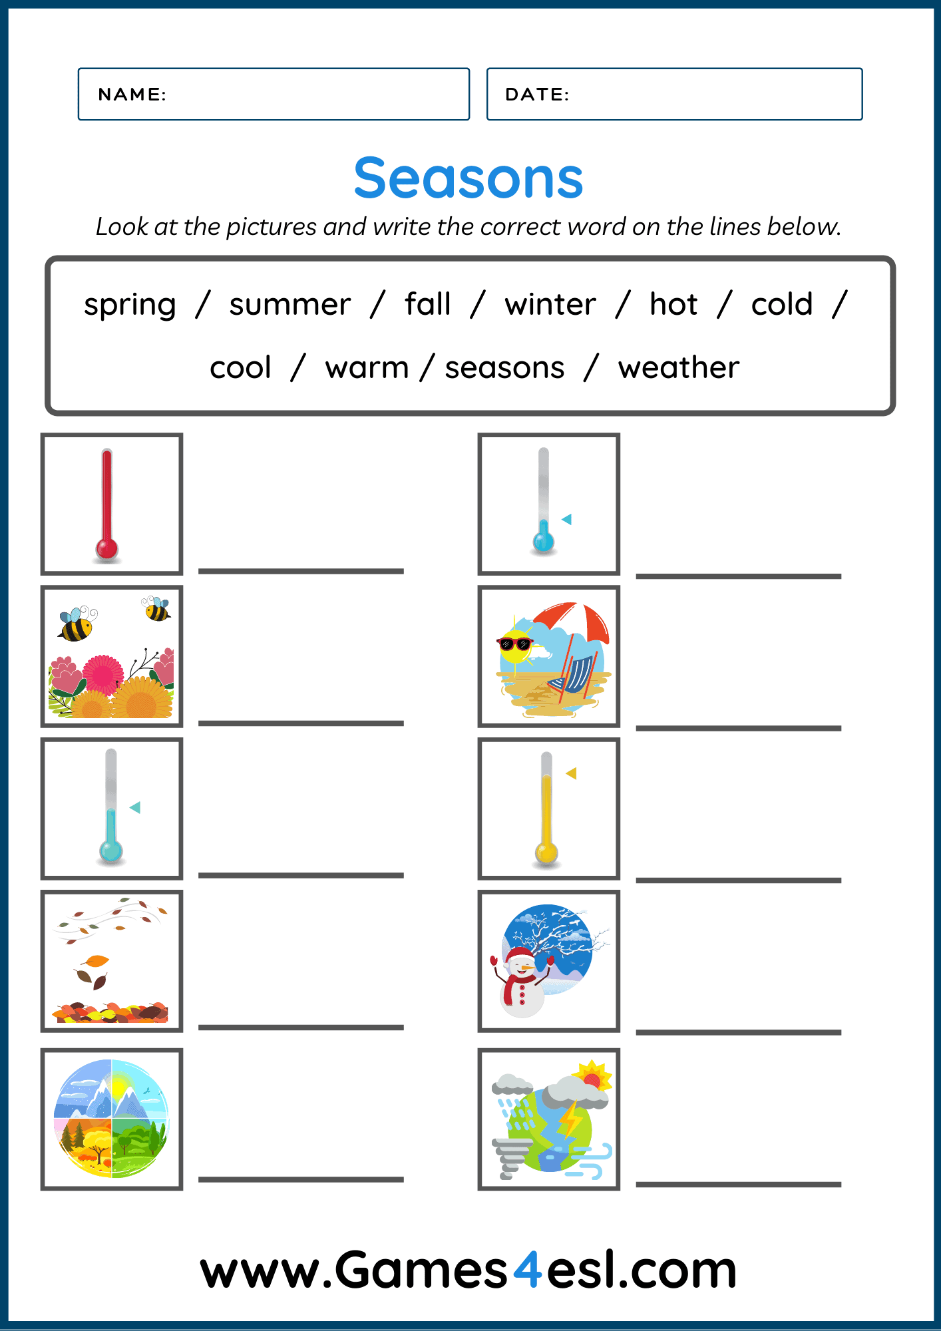
[10 marks]
Date: ___________
Answer the following questions given in the worksheet on the four seasons.
- How many seasons of the year do we have?
__________________________________________________________________________
- Name the four seasons
__________________________________________________________________________
- Which is your favourite season?
__________________________________________________________________________
- What do we wear in winter?
__________________________________________________________________________
- Write a sentence about your favourite season
__________________________________________________________________________ [8 marks]
Date: ______________
Fill in the blanks using the words below
four | jacket | summer | cold | Spring
coffee | hot | water | autumn | June

1. We have __________ seasons.
2. We wear ___________ in winter.
3. We swim in ____________.
4. Winter is _____________.
5. ____________ has beautiful trees.
6. I like drinking ____________in winter.
7. In summer it is _____________.
8. We drink plenty of ______________ in summer.
9. My favourite season is ________________.
10. Winter starts in _____________
Theme
Creatures living in water, ocean, river and pond
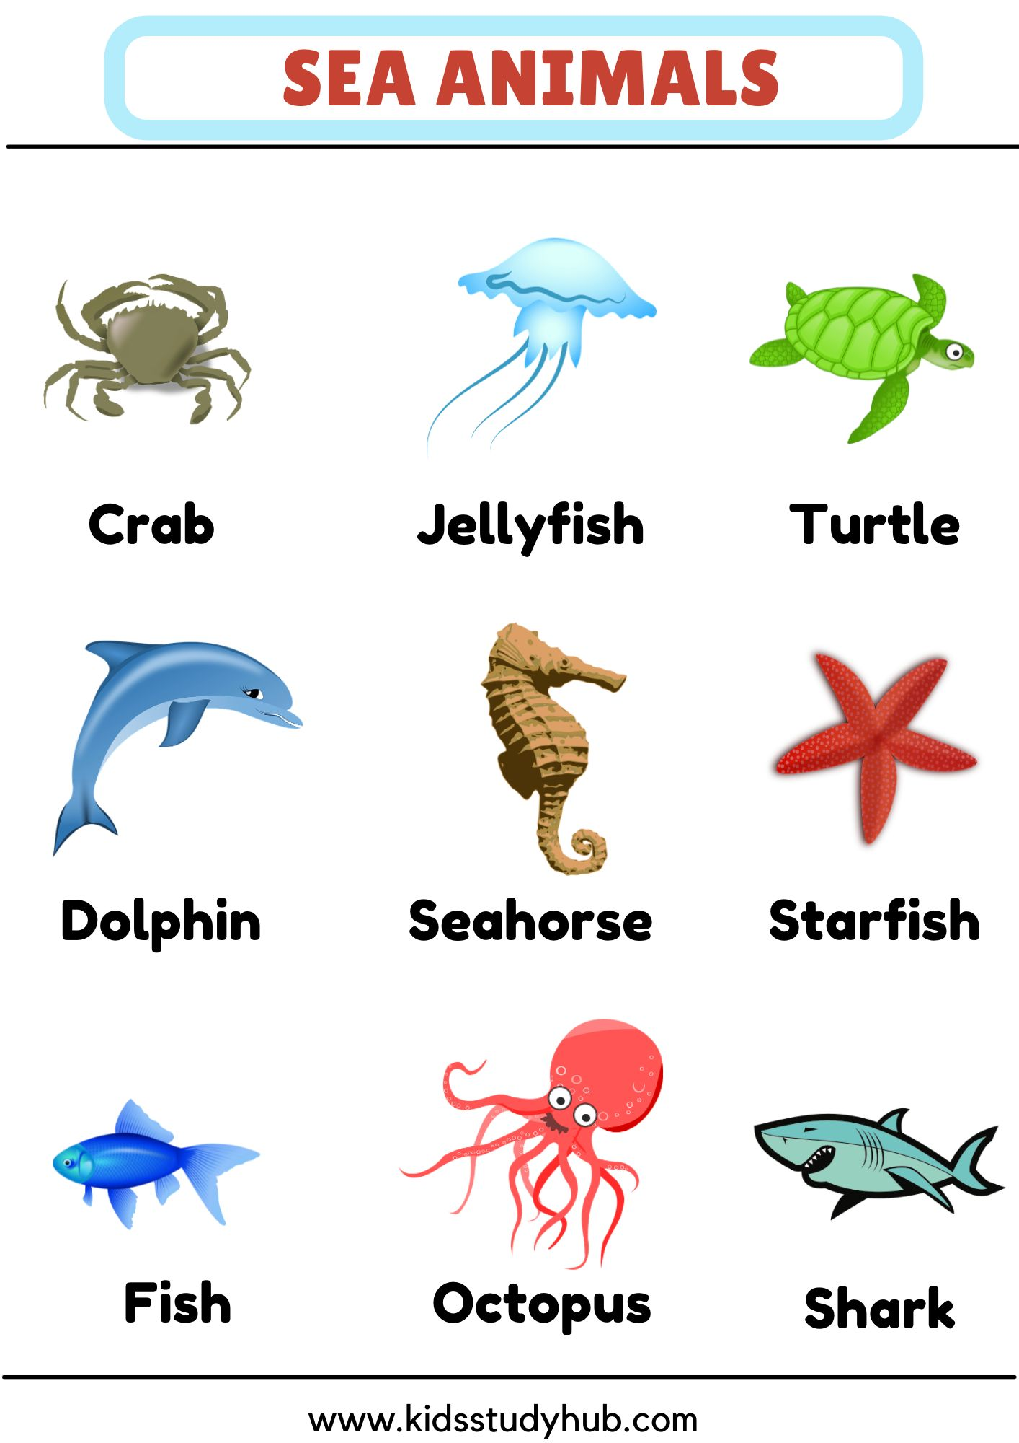

Group 1

Date: ____________
Colour the animals that live in the ocean.
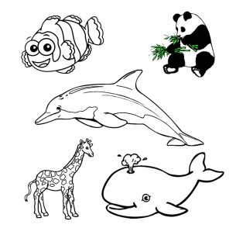
[3 marks]

Date: _____________
Colour the animals that live under the sea 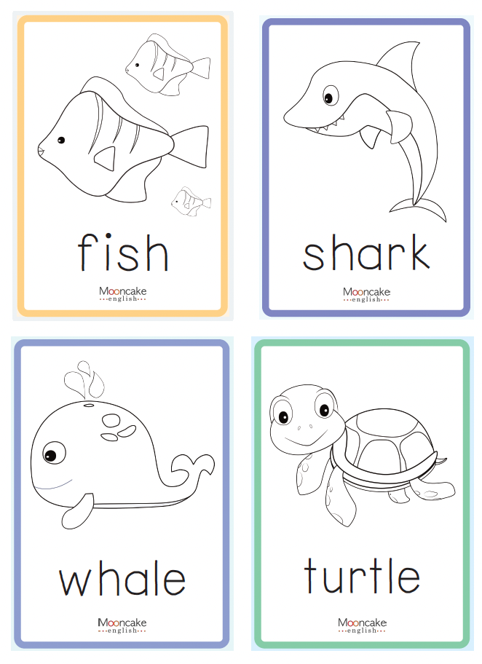 [4 marks]

Date: ____________
Sea Animals
Identify and match the sea animals.
Fish | whale
Tortoise | shark

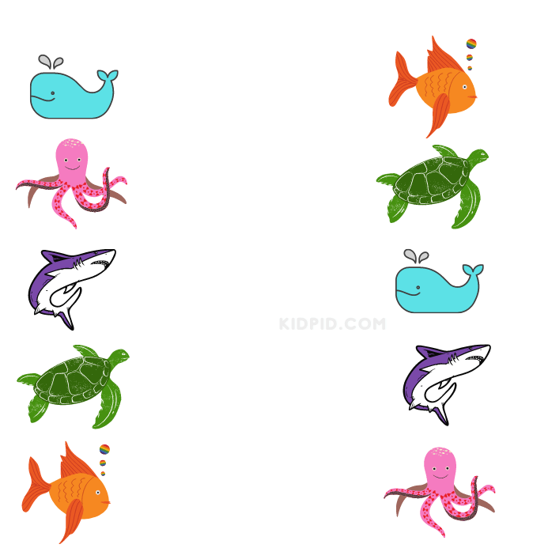
[ 5 marks
Group 2

Date: ____________
Fill in the blanks with the correct answer.
shrimp | Starfish | seahorse
shark | Seal

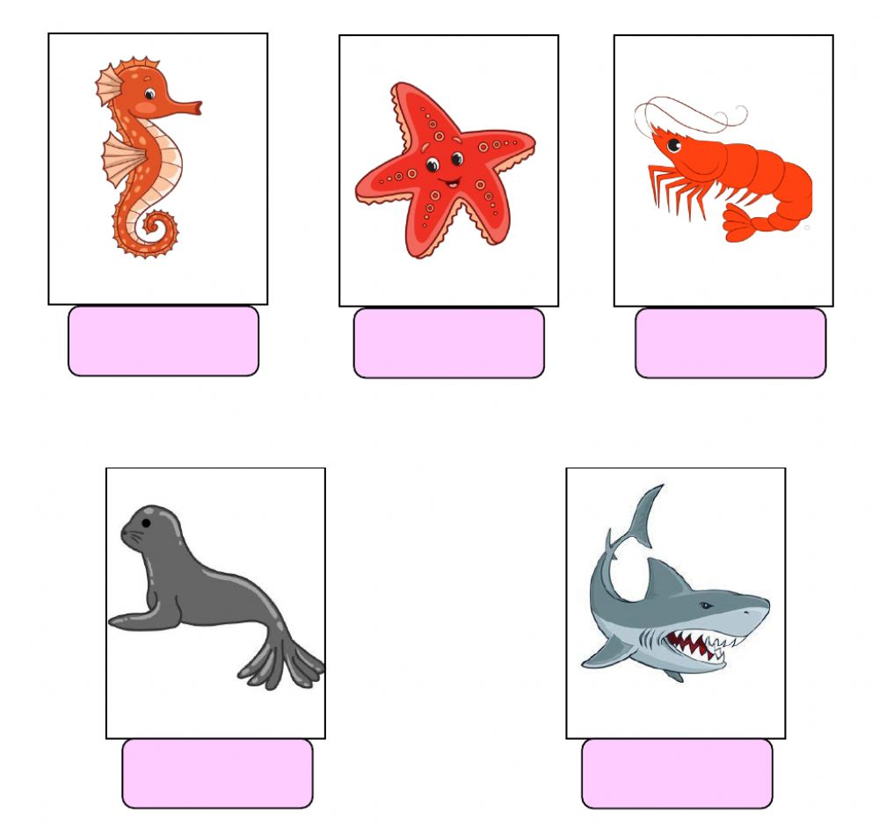
[5 marks]

Date: ___________
Sea Animals
Look at the pictures below and write the missing letters.
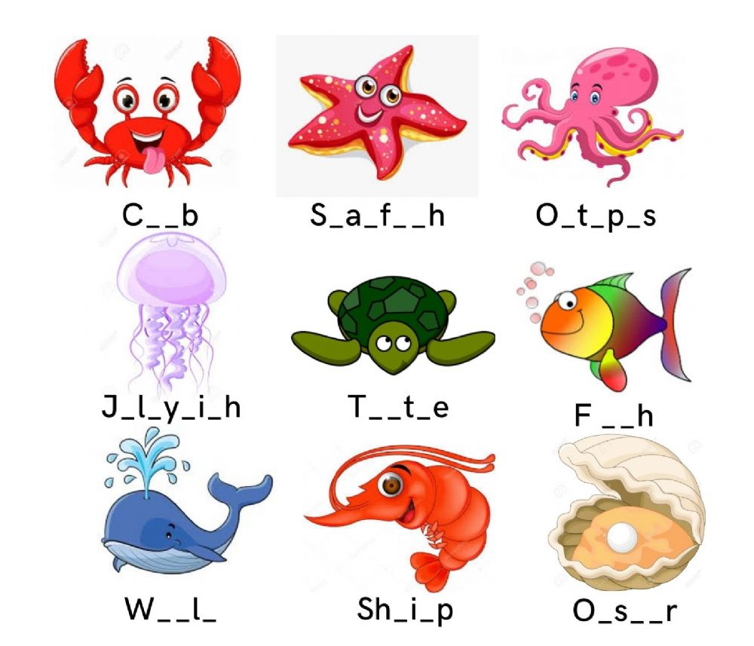

[9 marks]

Group 3

Date: ____________
Write the names of the sea animals.
shark | seahorse | whale | jellyfish | fish
crab | octopus | crab | lobster | turtile

- ______________________
- ______________________
- ______________________
- ______________________
- ______________________
- ______________________
- ______________________
- ______________________
- ______________________
- ______________________

[10 marks]
Date: ____________
Sea Animals
Write the missing letters to complete the names of the sea animals.
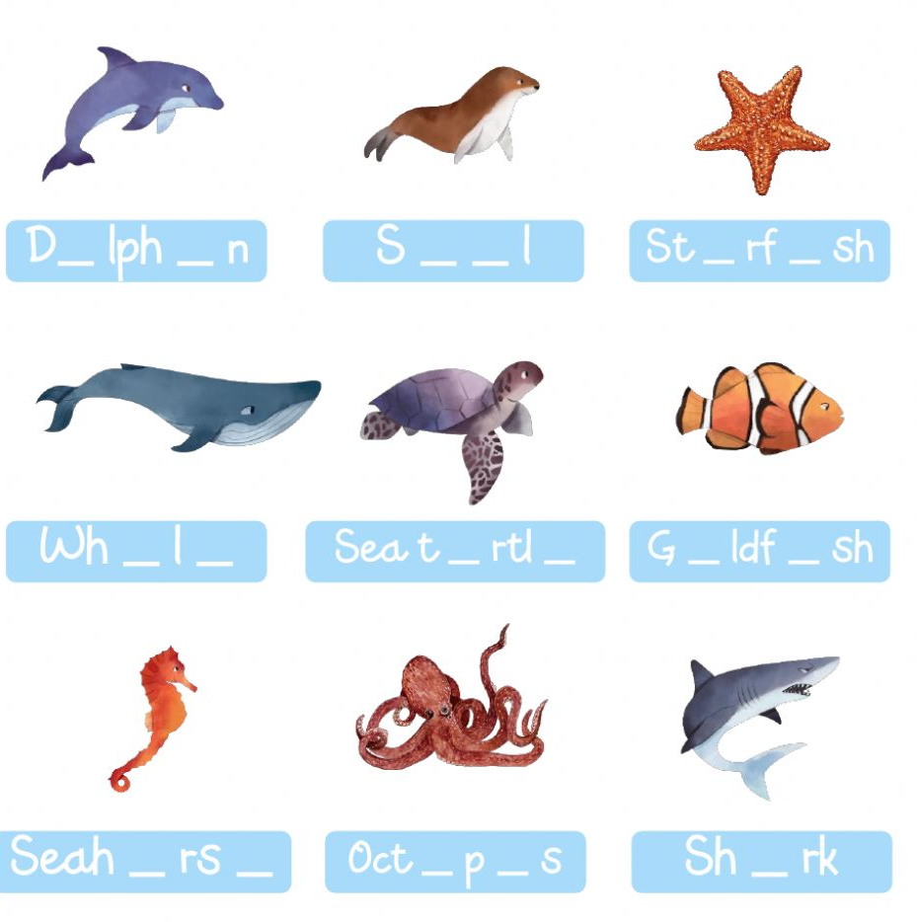
[9 marks]

Date: ____________
Life in a pond
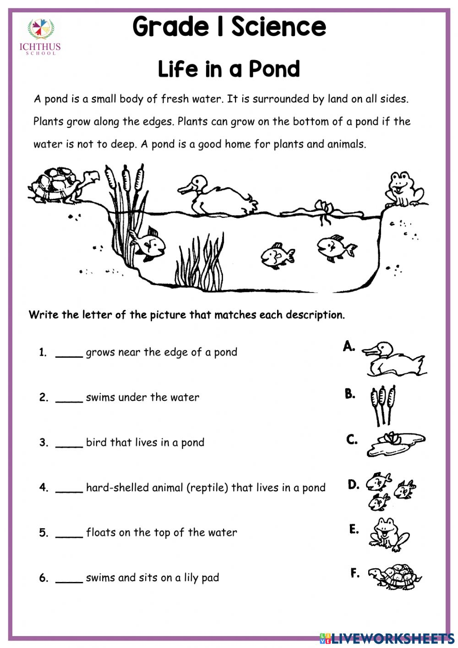 [6 marks]
Date: _____________
Write the sea animals with the correct answers.
crab | Eel | fish
jellyfish | octopus | seal
starfish | shark | walrus

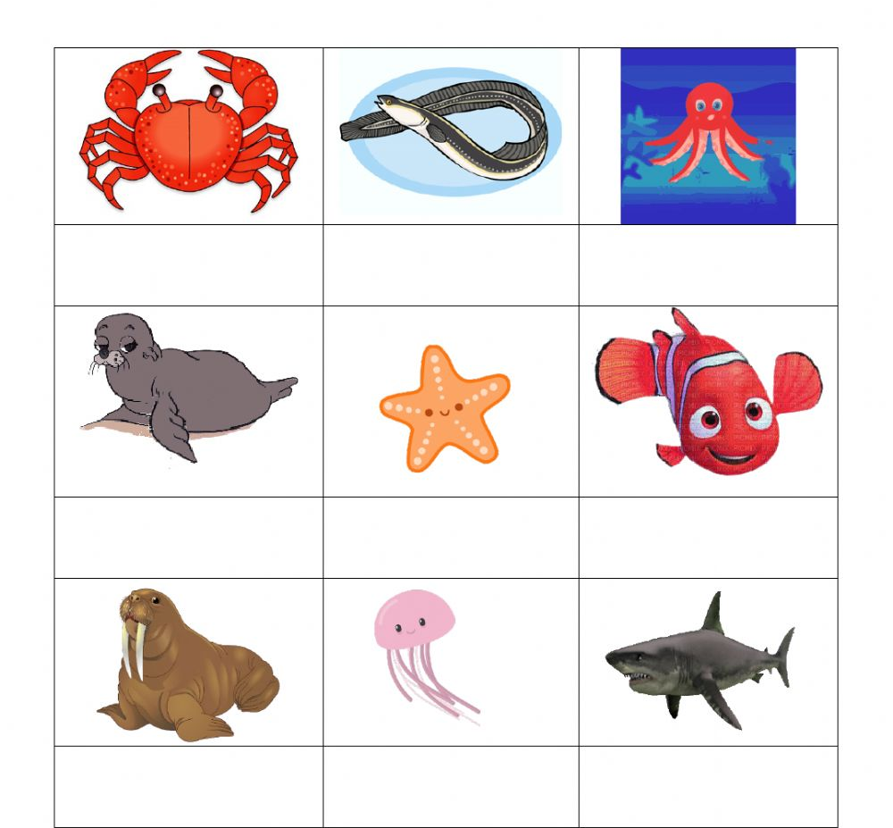 [9 marks]
Theme
Animals and their shelters
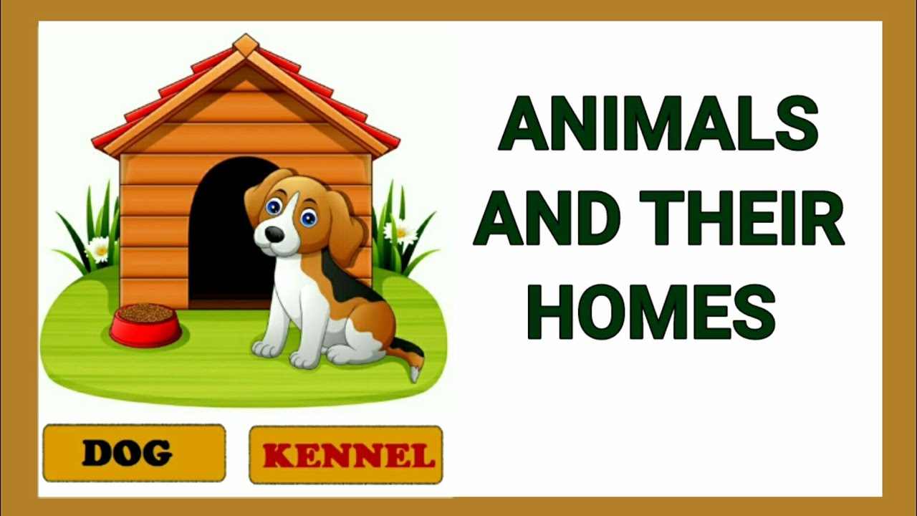

Introduction

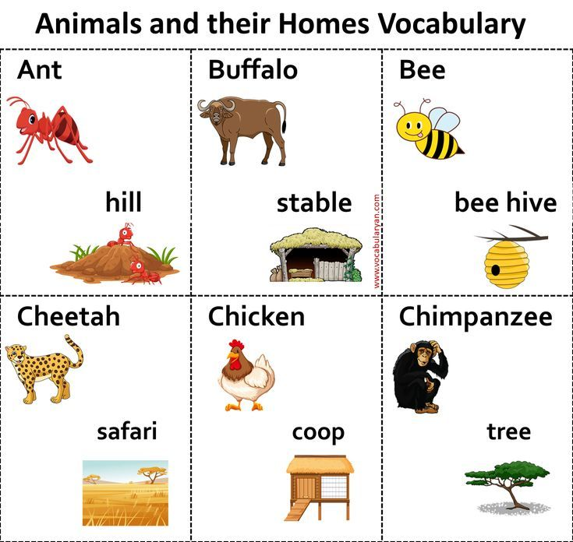

Group 1

Date: _____________
Oral task
Look at the picture and say the names and shelters.
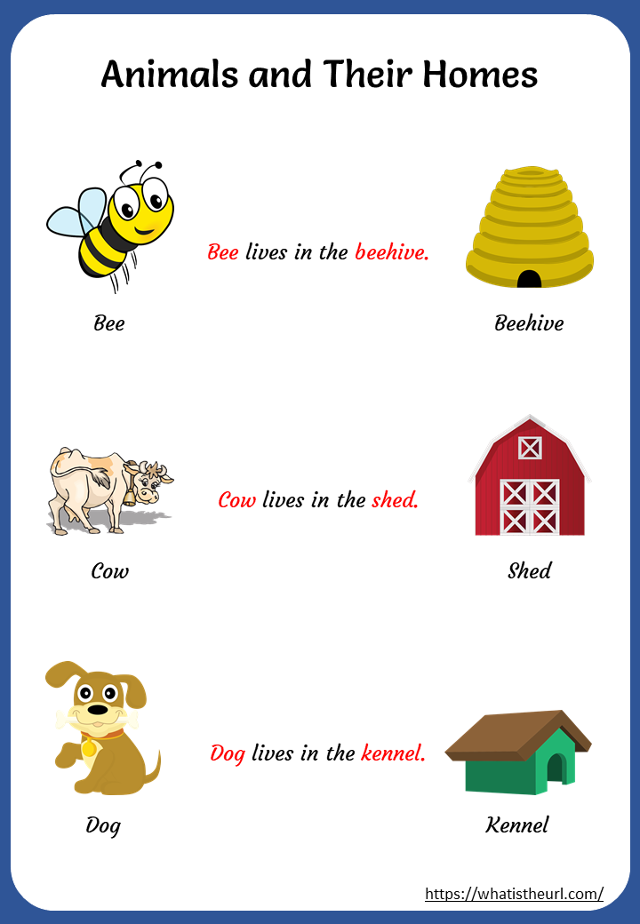 [5marks]
Date: ___________
Listening activity
Listen to the words and repeat.

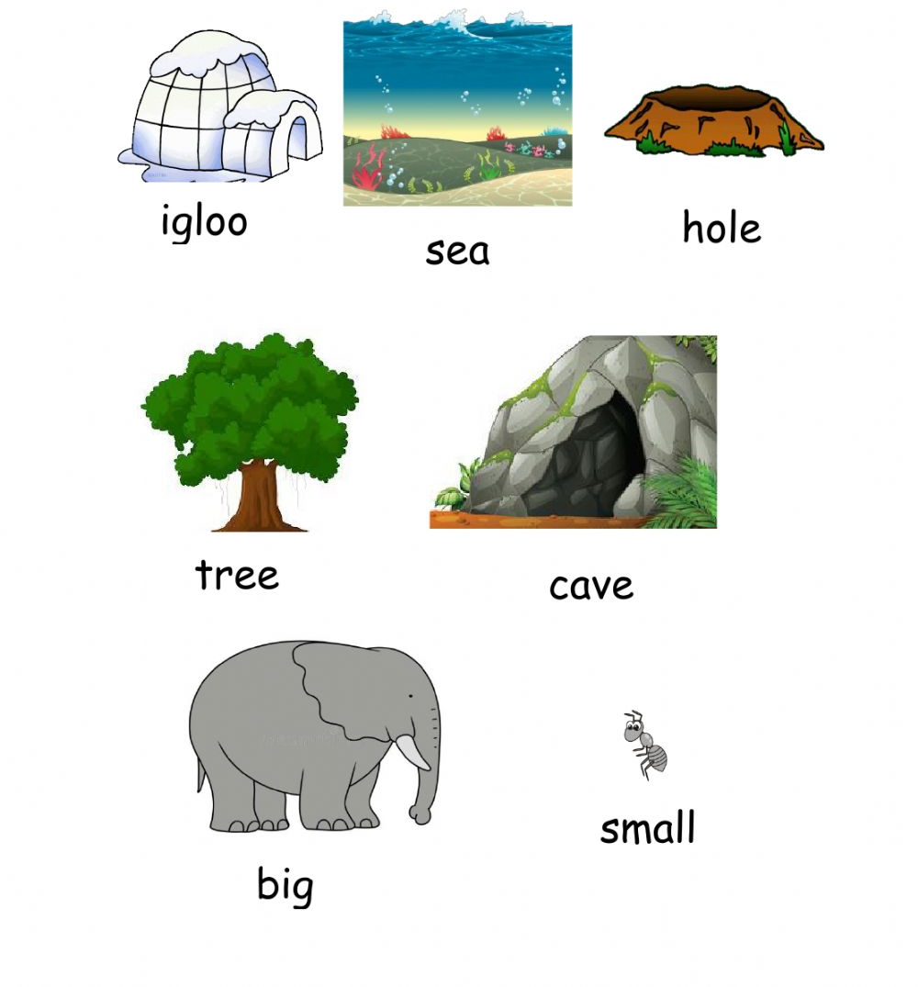
[7 marks]
Date: _____________
Animal Homes
Circle the correct answer for each picture
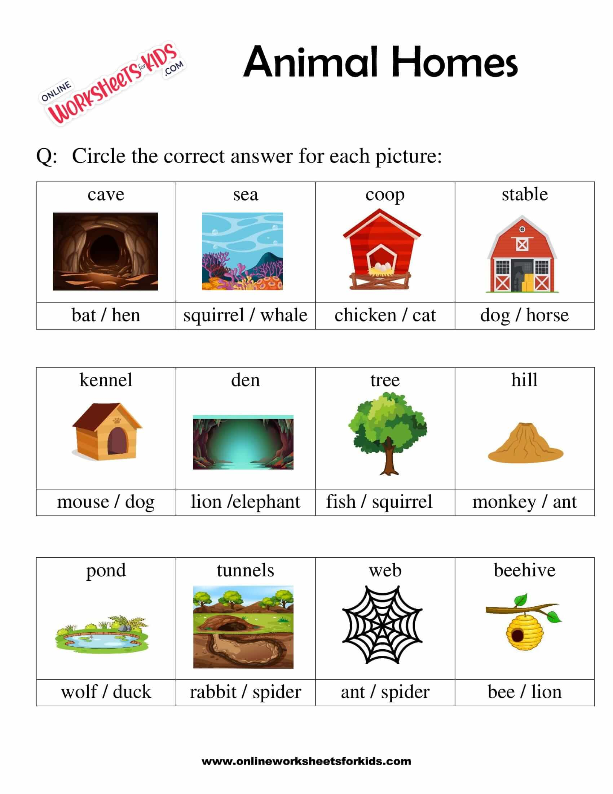

[12 marks
Group 2

Date: ______________
Match the animals and their homes.

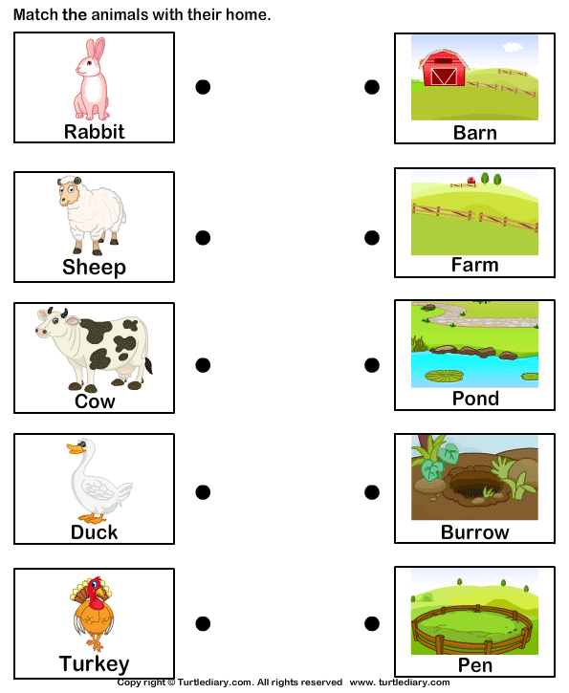
[5 marks]
Date: ________________
Choose the correct answer from the table below.
desert | stable | Kennen | burrow | nest | hive

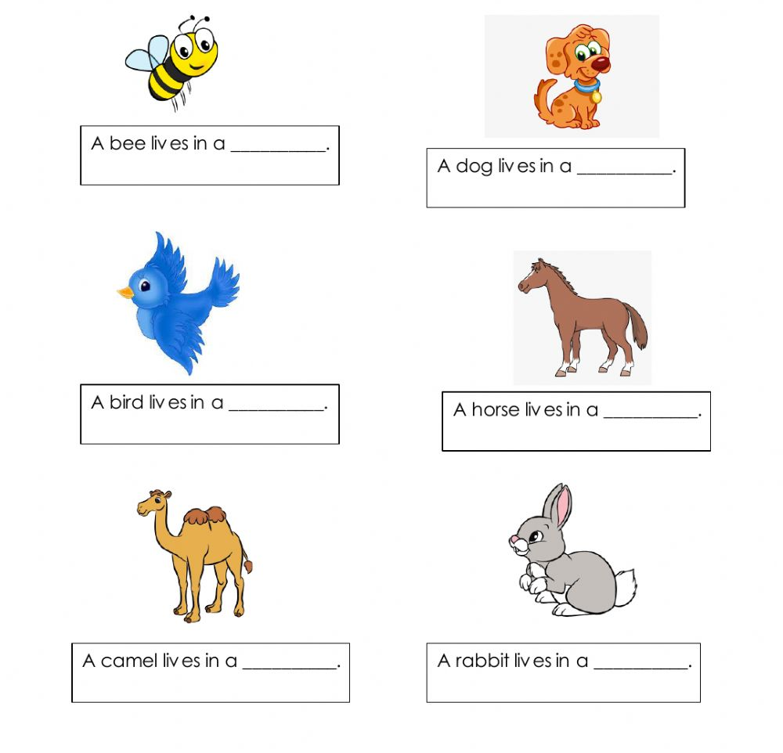
[6 marks]
Date: ____________
Write the names of animal homes under each picture.
mouse hole | hutch | beehive
den | sheep pen | tree hollow
cage | anthill | cave

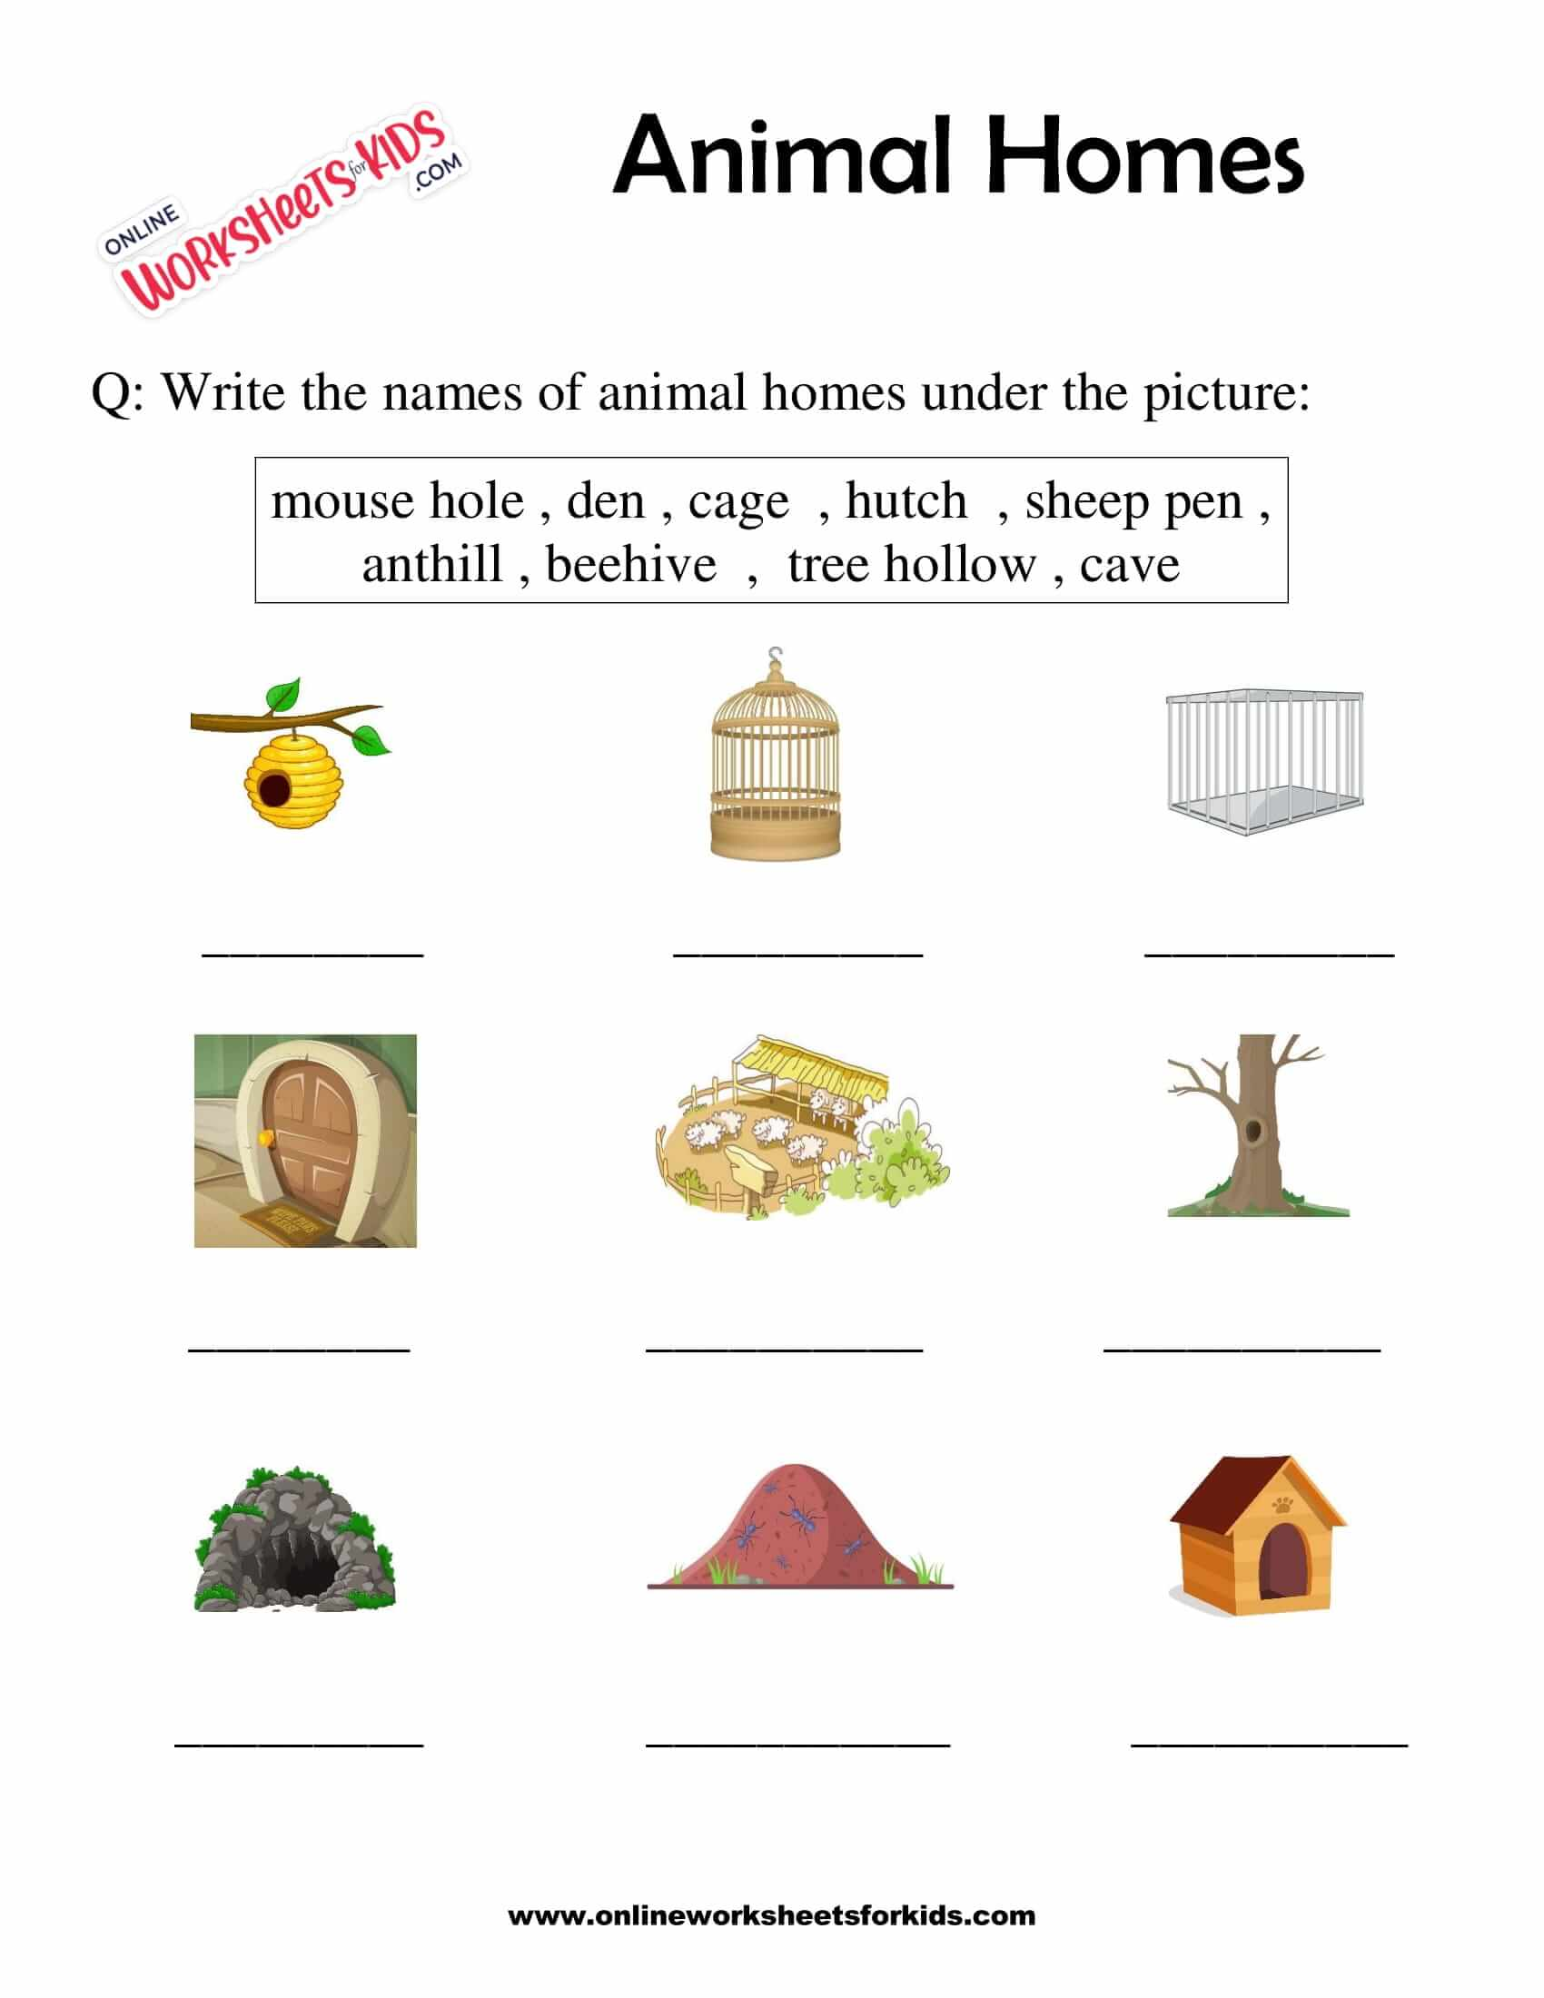
[9 marks]
Group 3

Date: _____________
Complete the following sentences by using the given words.
hen | coop | Den | kennel | nest | tree | forest

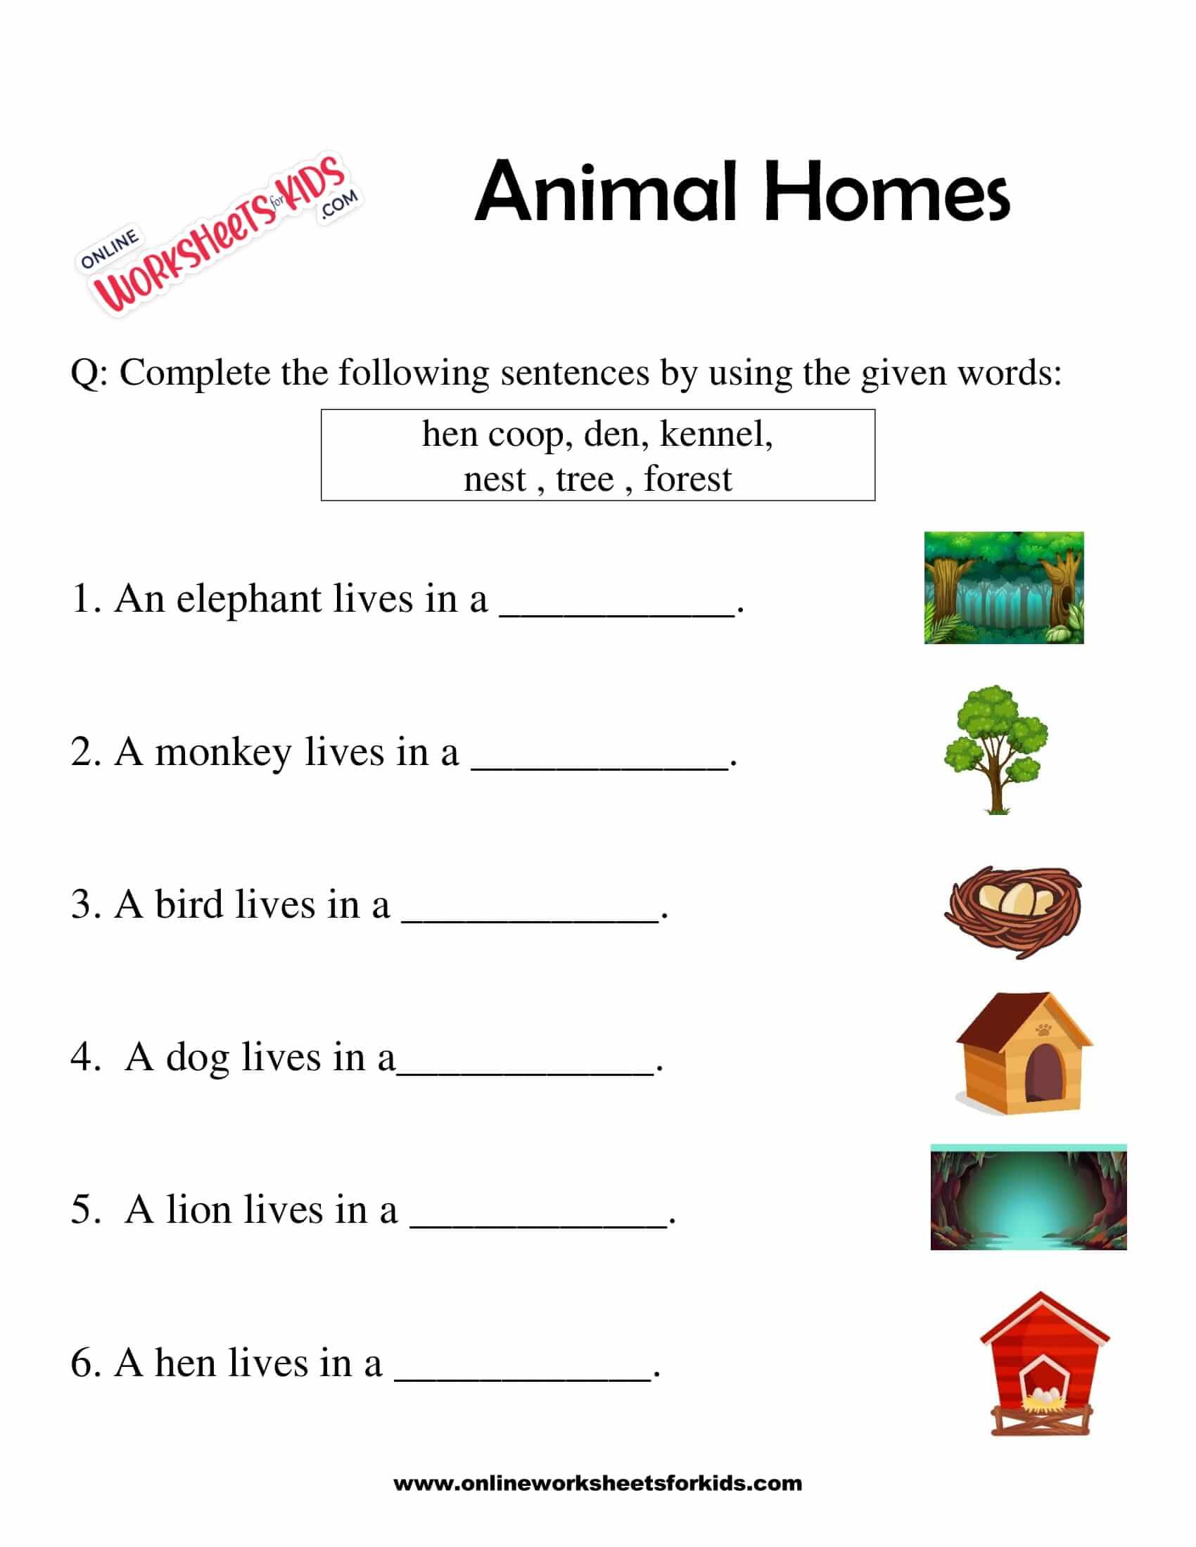
[6 marks]
Date: ______________
Look at the picture carefully and write the correct place.
nest | pond | beehive
den | cowshed | tree hollow
under ground | kennel | sea

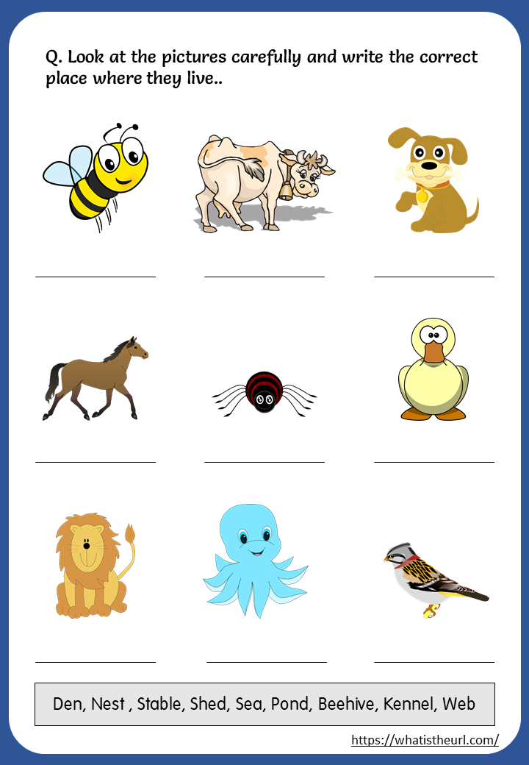
[9 marks]
Date: ______________
Animal Homes
Find the animal homes hidden in the puzzle below.
beehive | stable
kennel | tree hollow
burrow | cage
den | pond

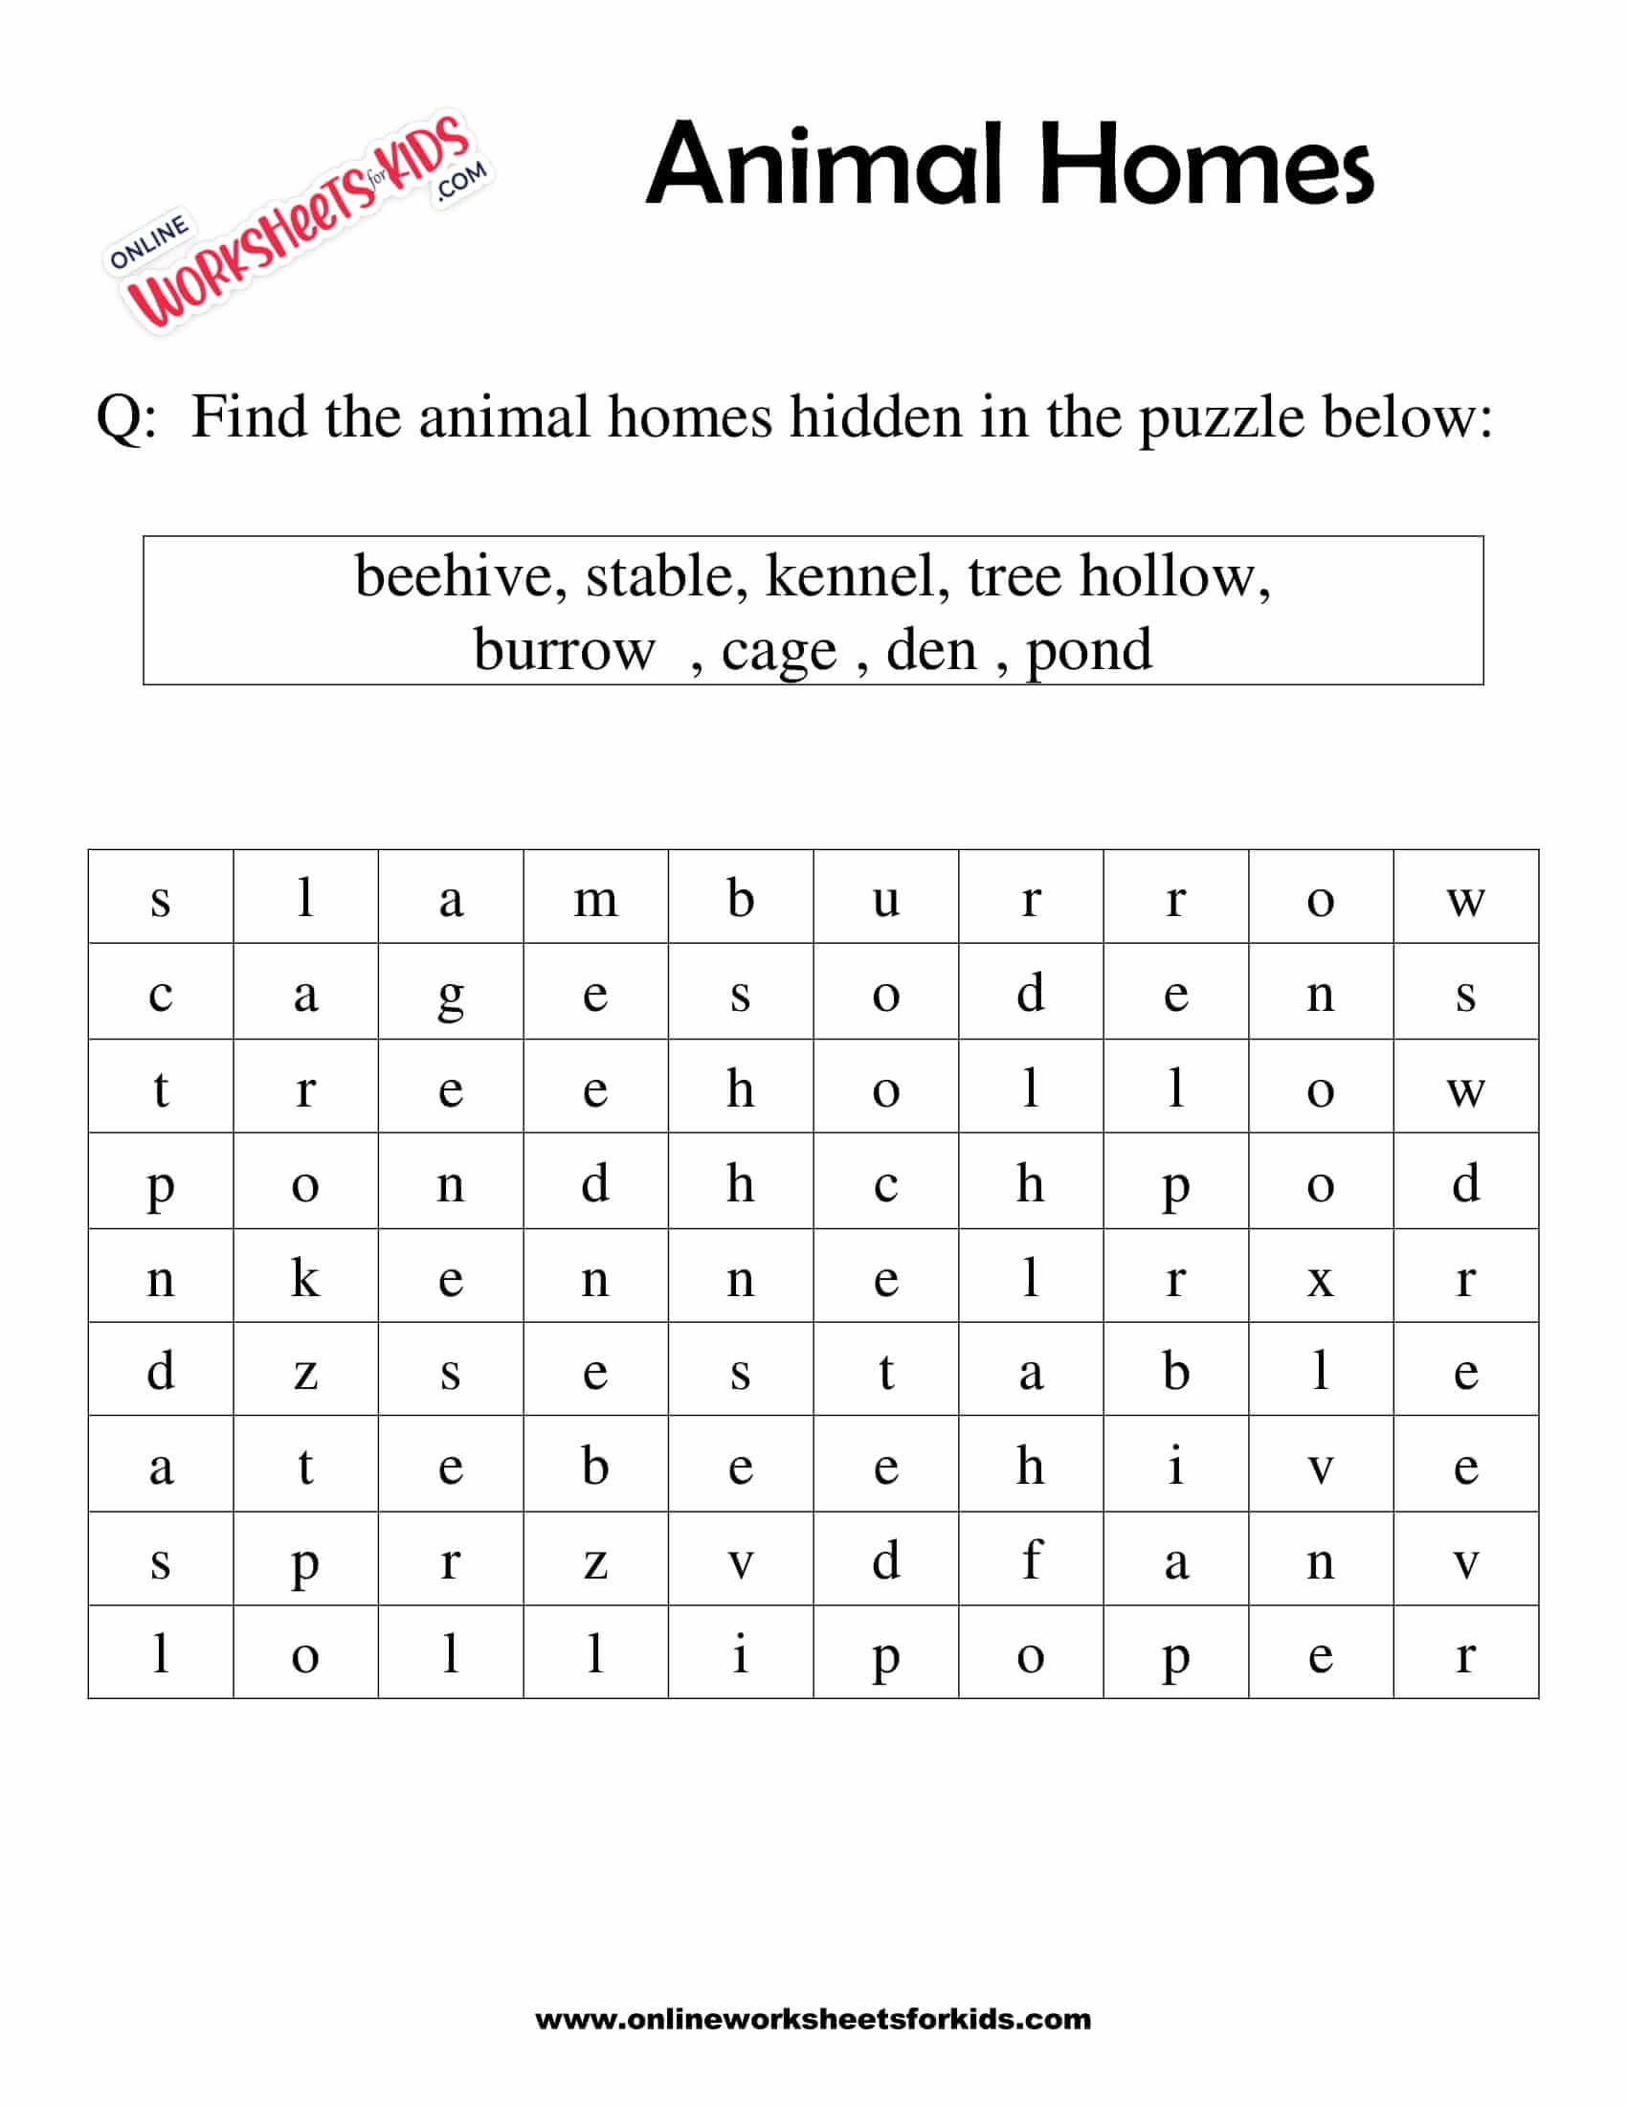
[8 marks]
Theme
Farm animals and wild animals

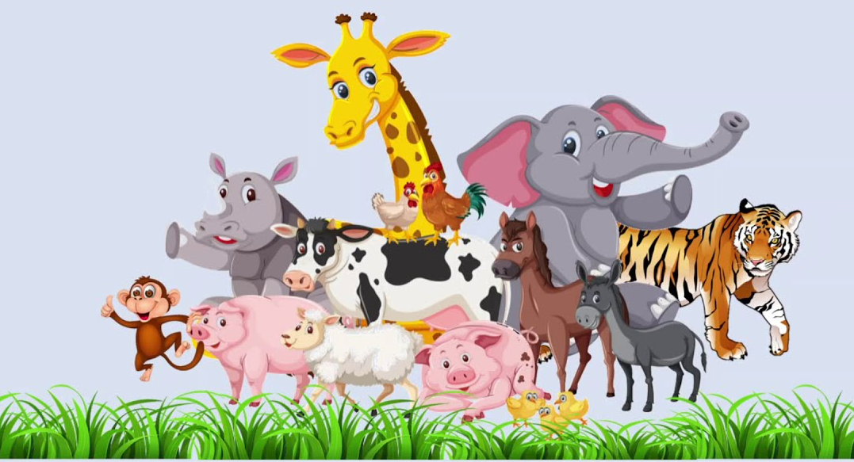

Introduction

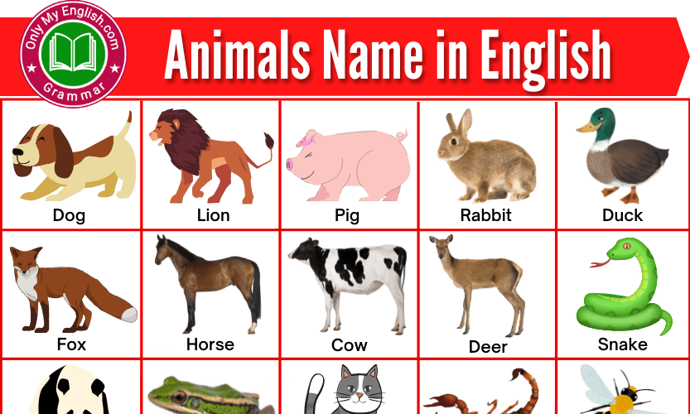

Group 1

Date: ____________
Types of animals
Trace the following words

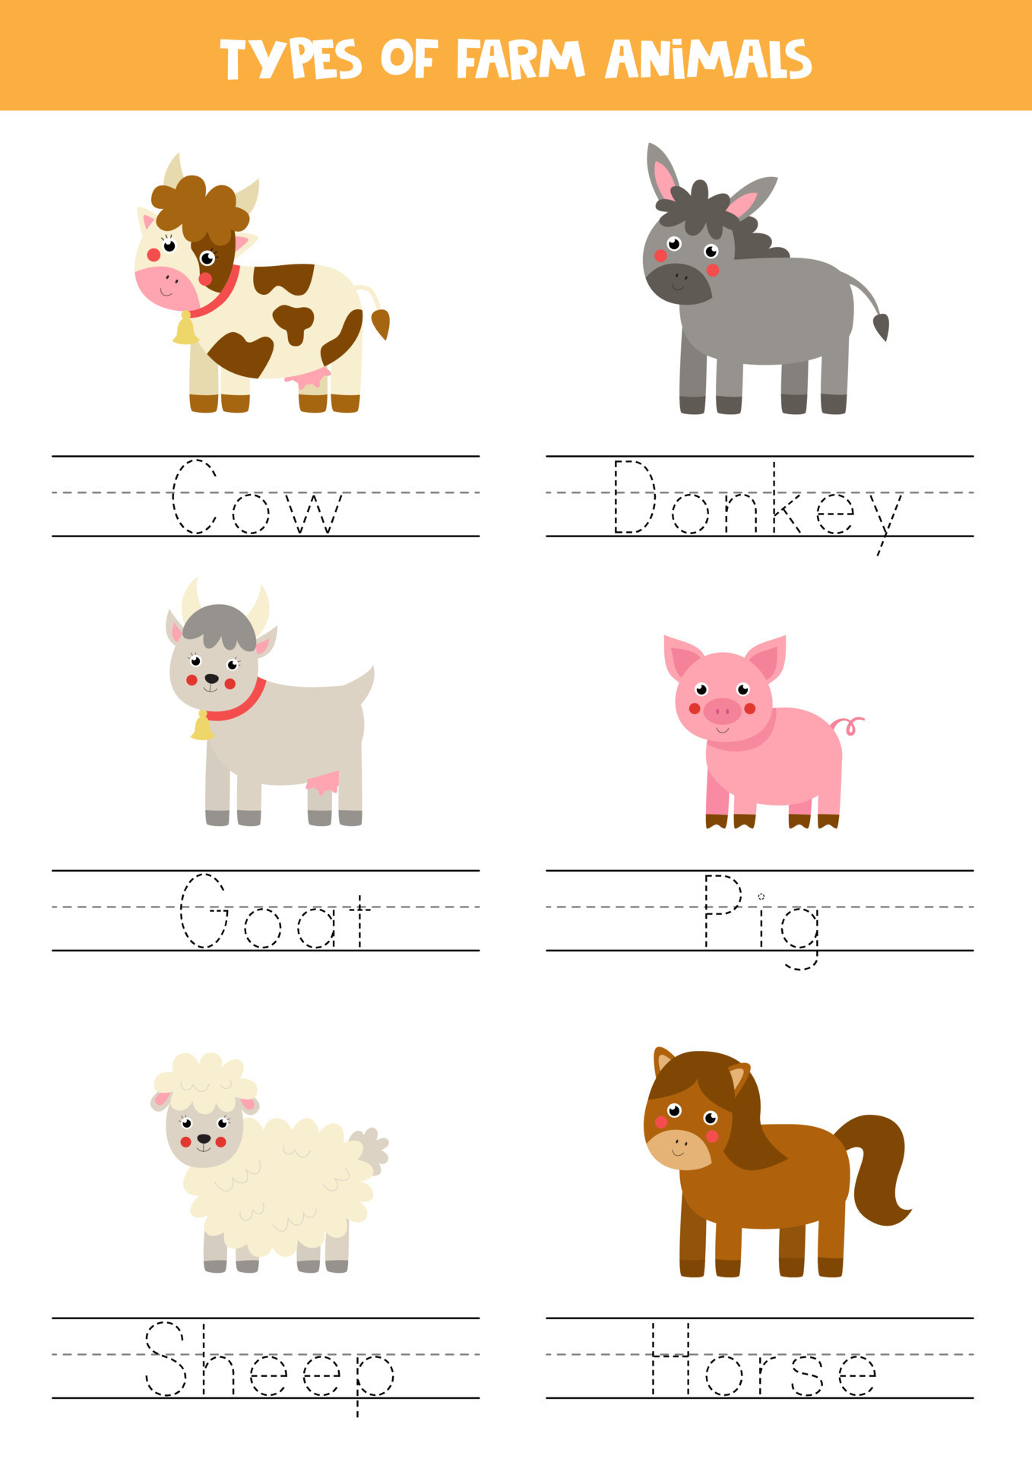 [4 marks]
Date: ________________
Trace the farm animal words

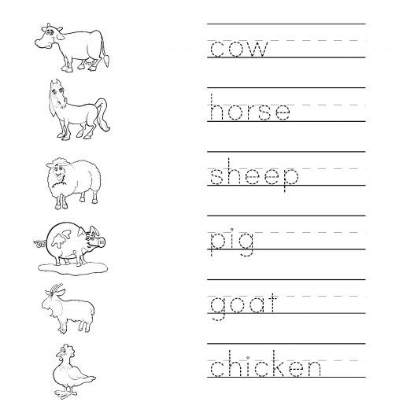
[6 marks]

Date: ______________
Match the following animal name

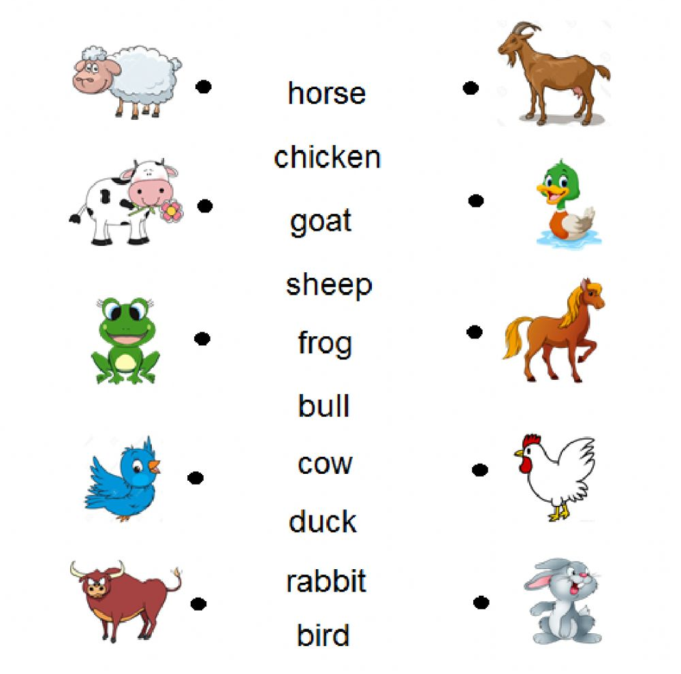
[10 marks]

Group 2

Date: ______________
Look at the picture and circle the correct word.

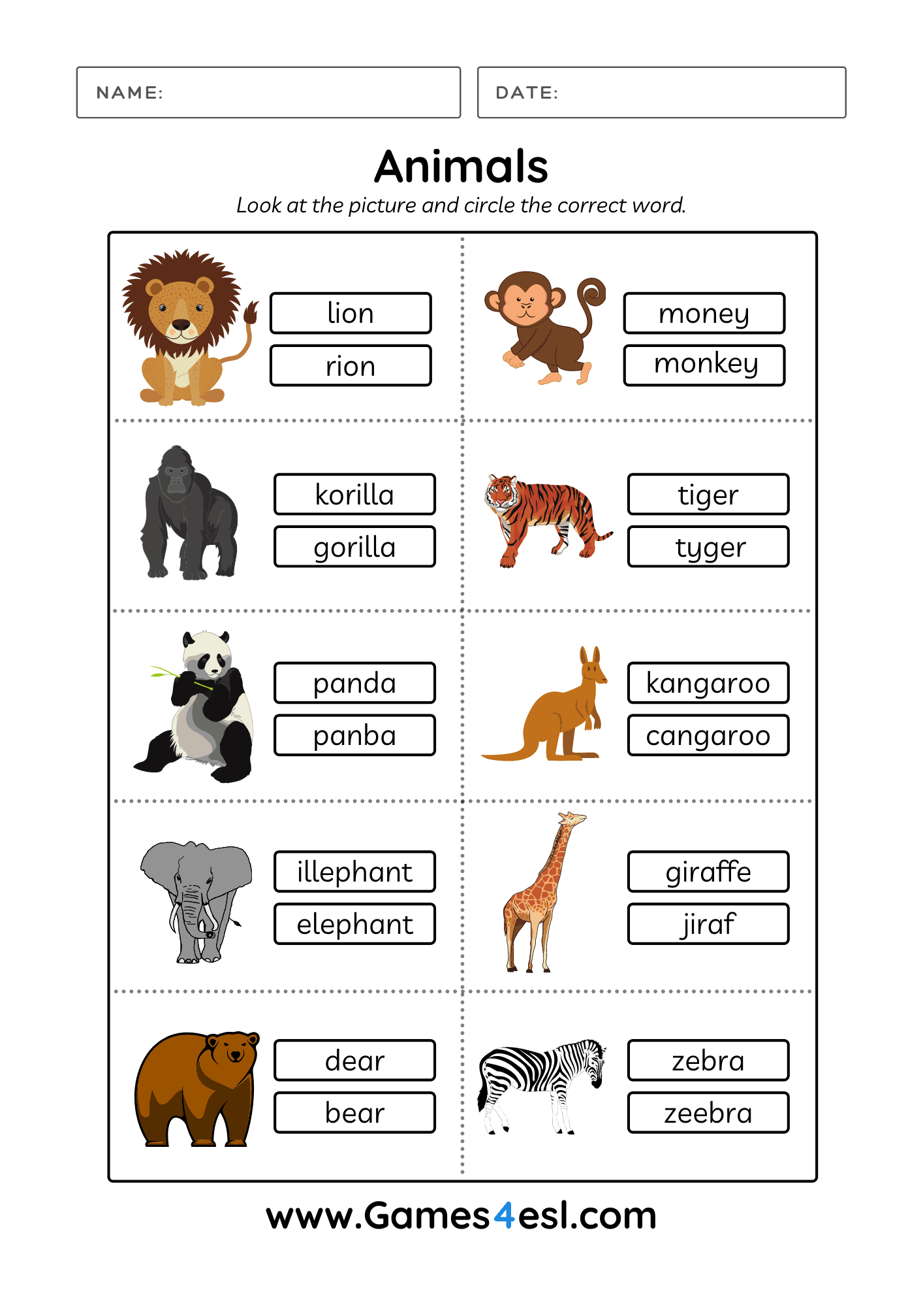
[10 marks]
Date: ______________
Farm animals word scramble
Look at each farm animal picture and unscramble the letters and write the name of the farm animal on the line.

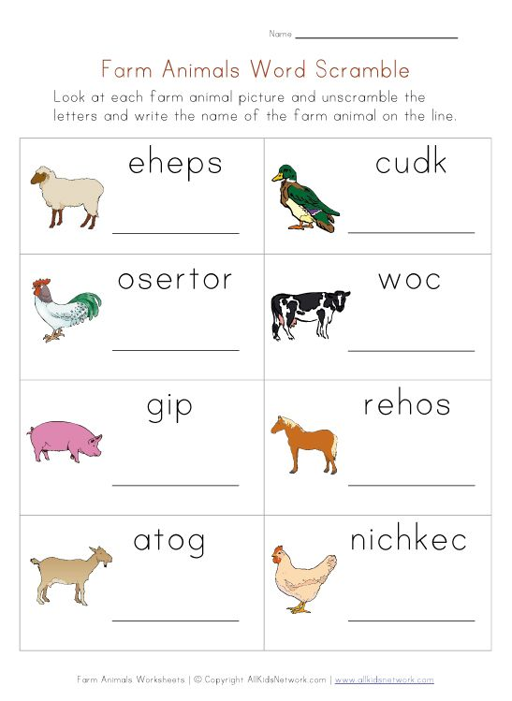
[8 marks]
Date: ______________
Match the following words with the correct animal.

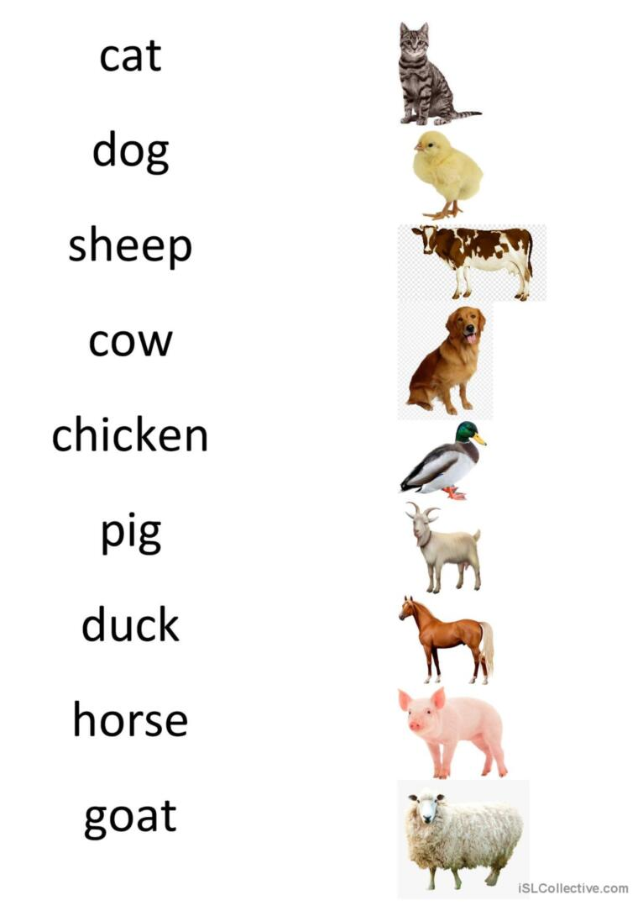

[9 marks]
Group 3

Date: _____________
Fill in the missing letters
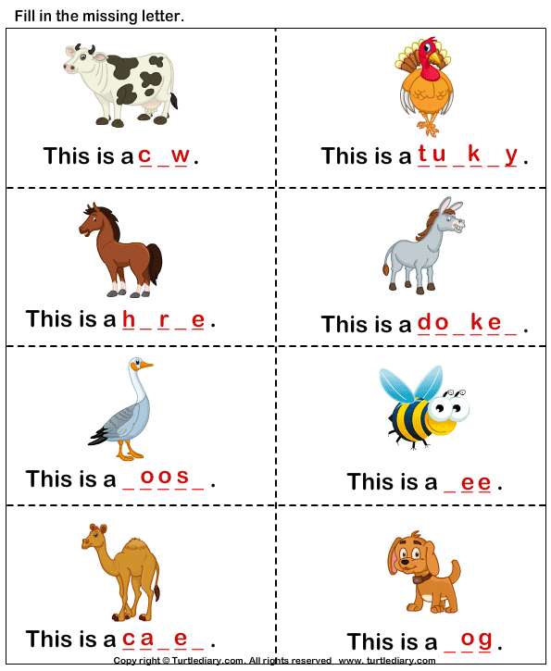

[8 marks]

Date: _______________
Choose the correct house for each animal.

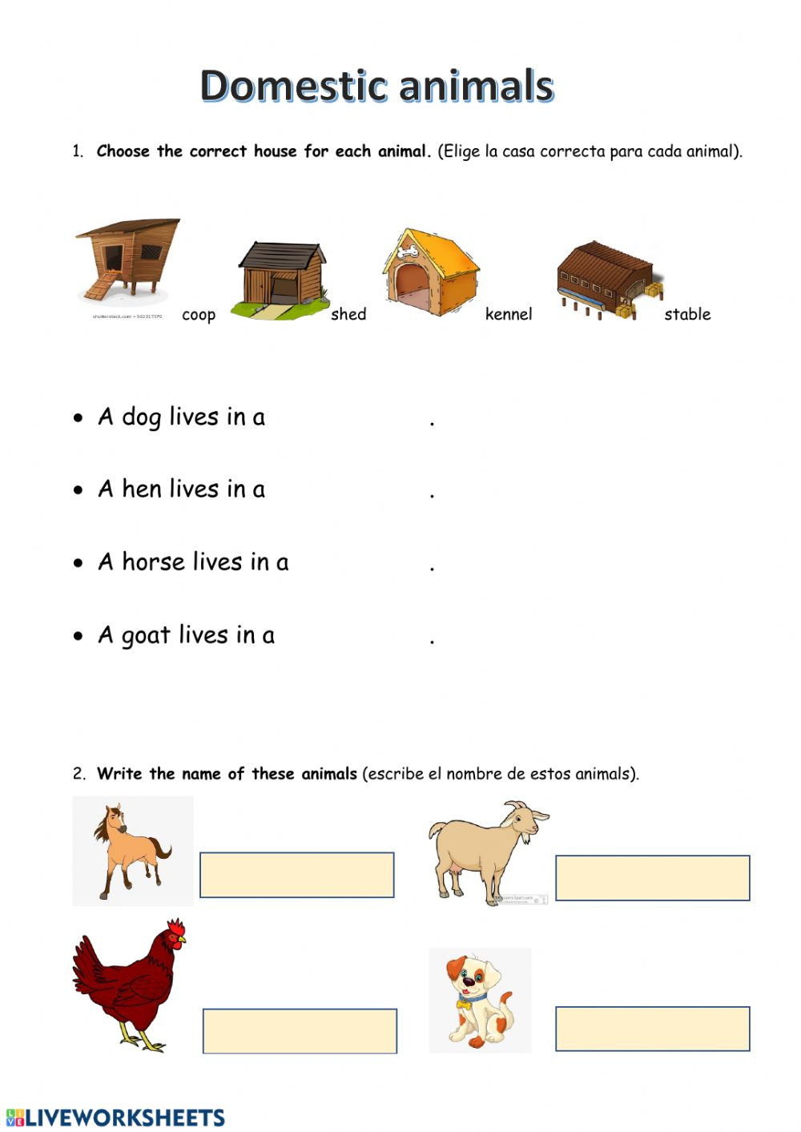 [4 marks]

Date: ______________
Look and match
bee | chicken
cow | goat
pig | sheep
duck | donkey

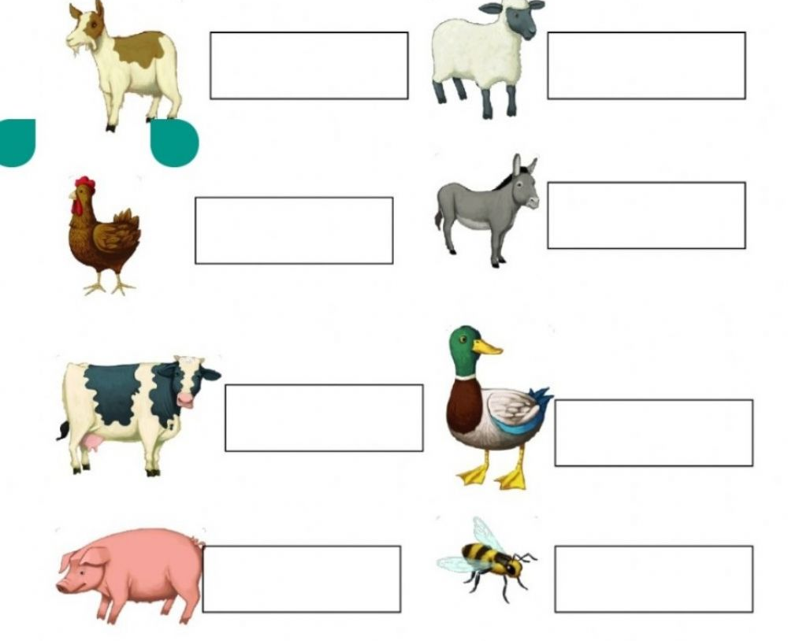
[8 marks]

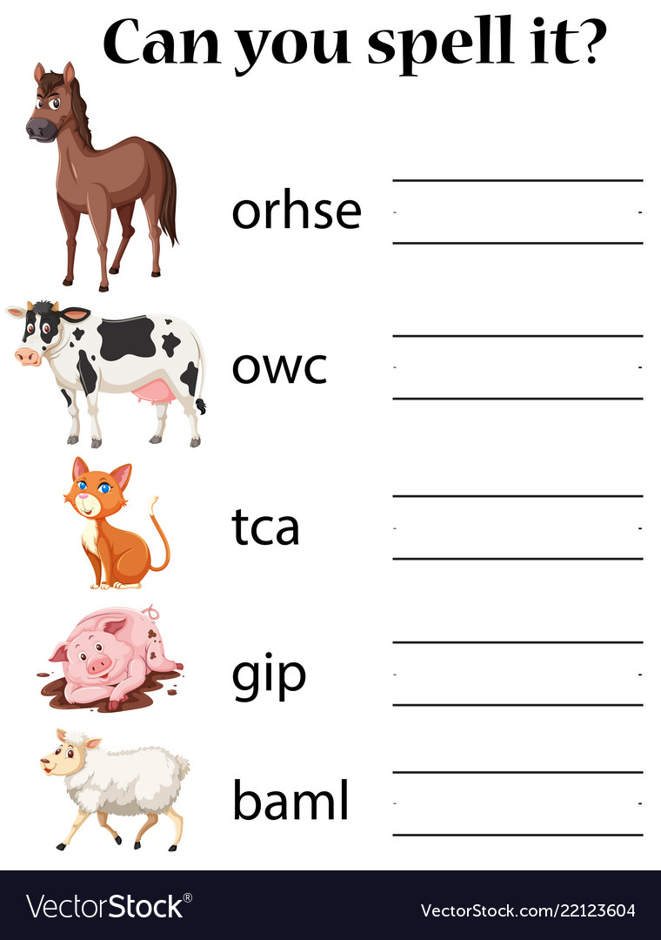

Reference list

